**ASSUMPTIONS:**

**1.** Have implemented only purchase order module

**2.** Vendor module is implemented by some others so there are already vendors exists in the database.

**3.** Also the medicine sells by the vendor is filled in the database.

**4.** Presume that Login and Validation is done by others.

**Dashboards Screen.**

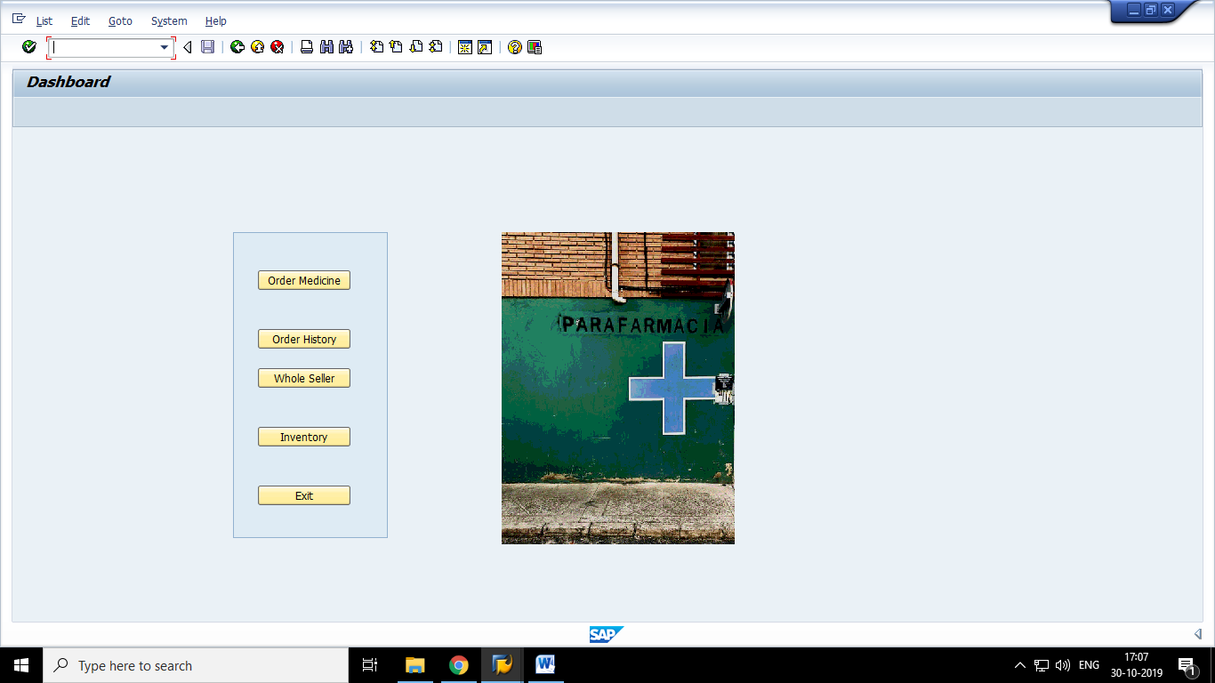

**When user click on the ‘Order Medicine’ button to purchase the medicine from whole seller. A new screen will appears like this .**

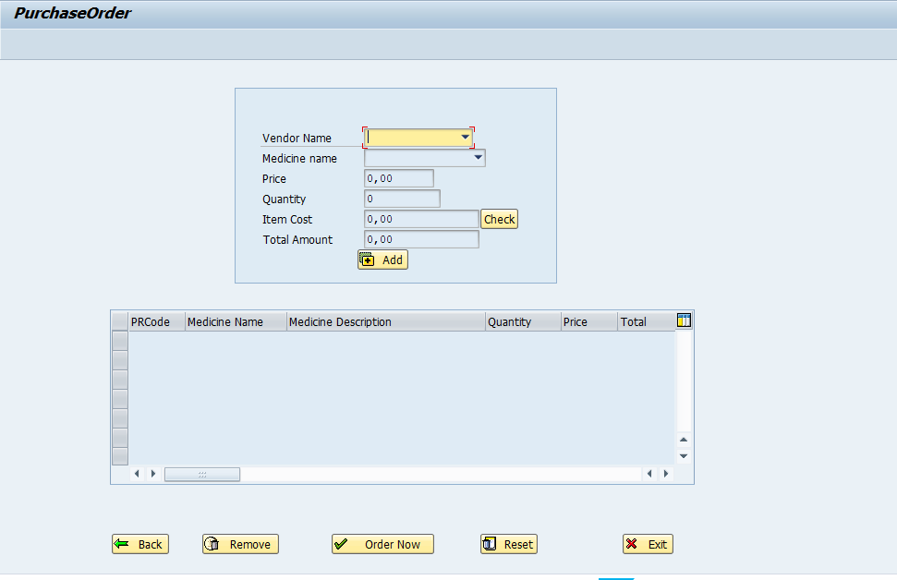

**The flow of order is like this.**

1.First you have to select the vendor by whom you want to by the medicine from the drop down.

2.In the second dropdown it will display medicine list which is selling by the vendor, who is selected in first drop down.

3.After selecting the medicine, you have to enter the quantity of the medicine .

4.And click on the ‘Add’ button.

5. For adding more medicine, repeat step 2 to step 5 .

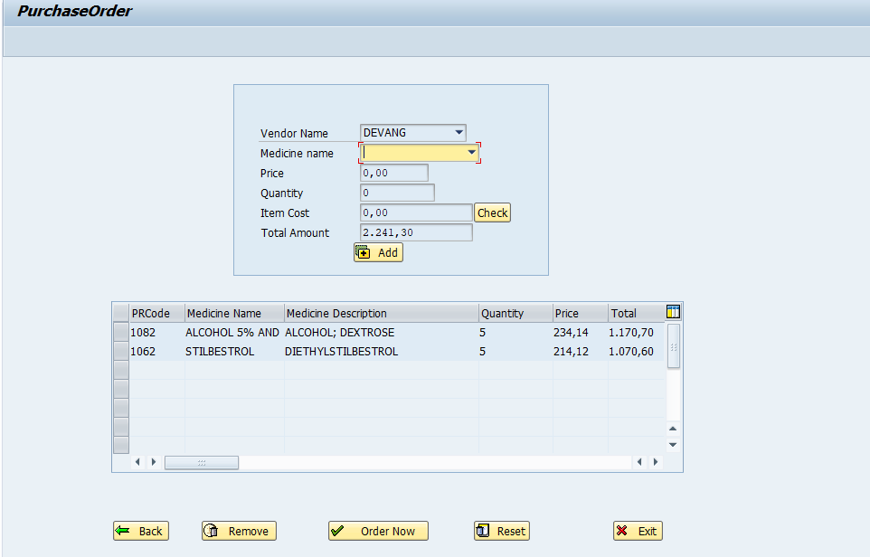

**If you want to delete some medicine, select the medicine from table control, click on remove button.**

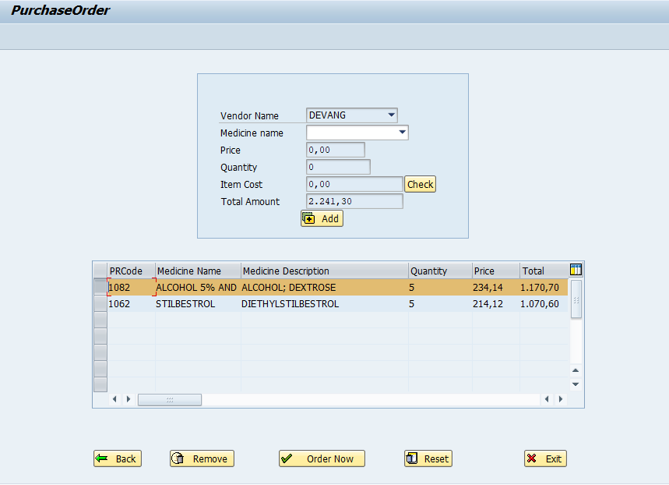

**For order, Click on the ‘Order Now’ button. It bill create a bill in PDF form.**

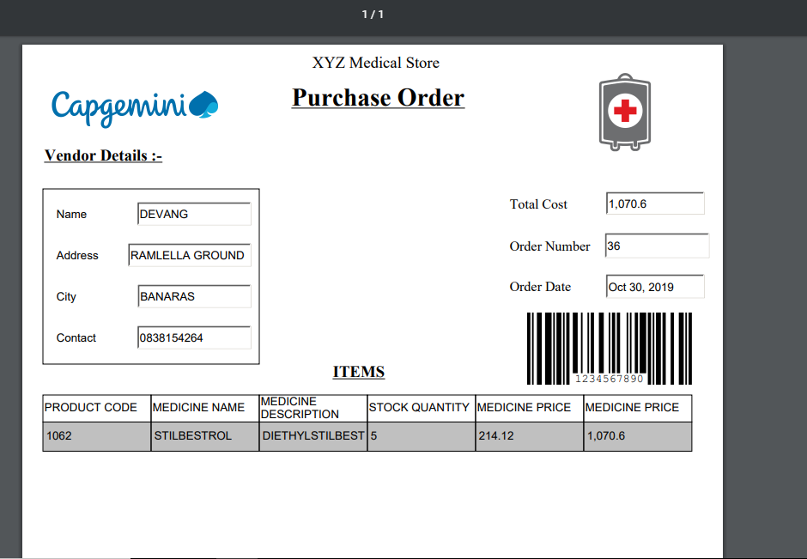

Reset button is to reset the table and screen.

**To see the history of order we click on “Order History” button from the dashboard which will display the all the order whether it is pending or received**

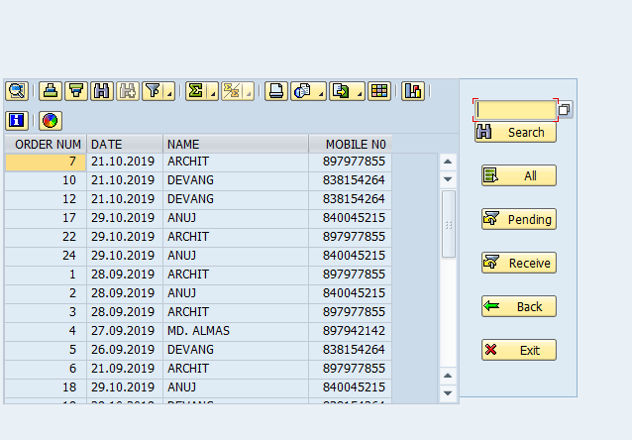

When we click on Pending Button in above screen we will get the details of pending orders i.e. the orders which has been not yet delivered

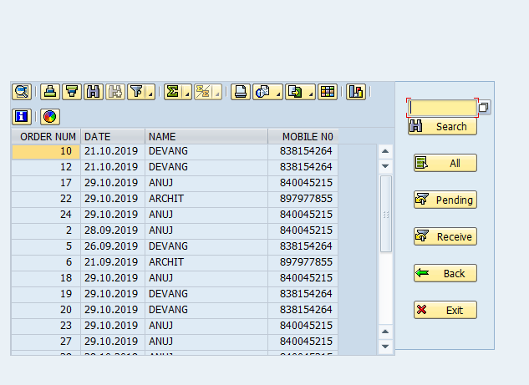

**Similarly if we click on Receive we will get the list of all the received orders.**

**By clicking on search help in the search field we get the option of search help as well.**

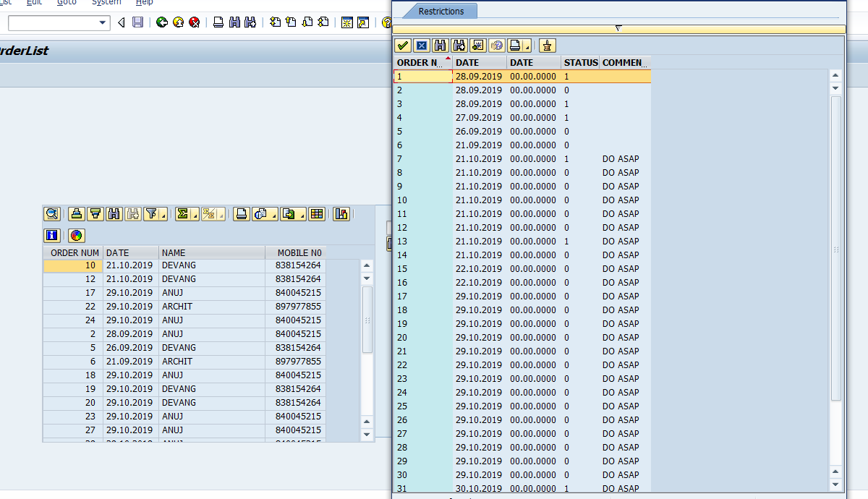

**Now if we double click on any order we will get the history of that order.**

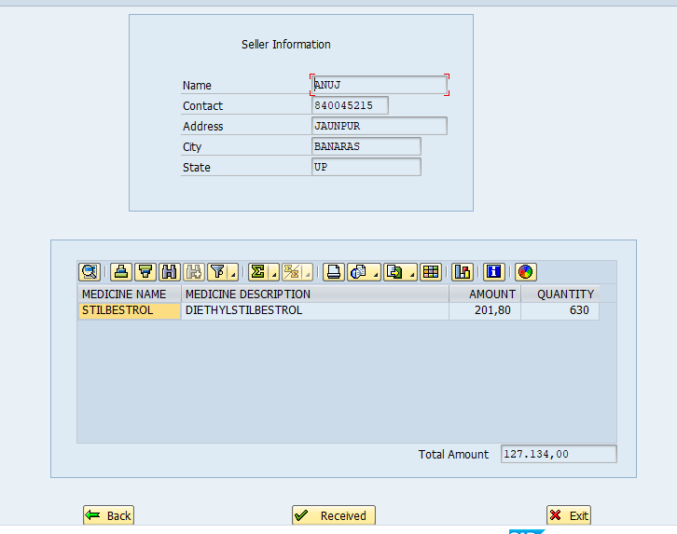

**In the above screen we can update the status from Received to delivered and the order status will become received.**

**When we click on “Whole Seller” from Dashboard we will get a list of all the vendors**

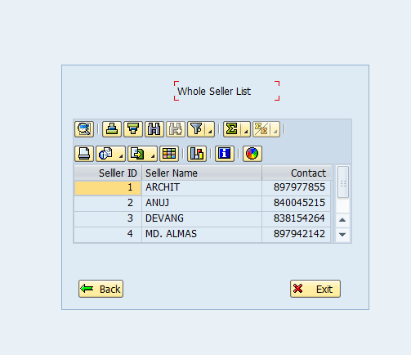

**Now if we click on any Seller Id we will get the contact details of that vendor/whole seller**

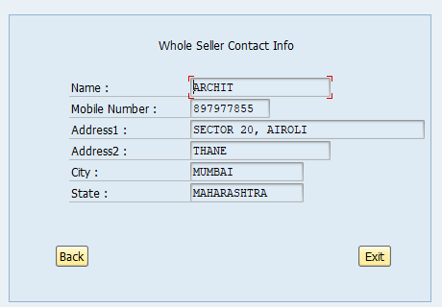

**If we click on “Inventory” from Dashboard we will get the list of all medicines in the Inventory**

